23.49.0.235 IPv4 Hosted by Akamai Technologies, Inc. Akamai Technologies, Inc. United States of America

2600:1406:2e00:3a5::1aca IPv6 Hosted by Akamai International B.V. Akamai International B.V. United States of America

2600:1406:2e00:390::1aca IPv6 Hosted by Akamai International B.V. Akamai International B.V. United States of America

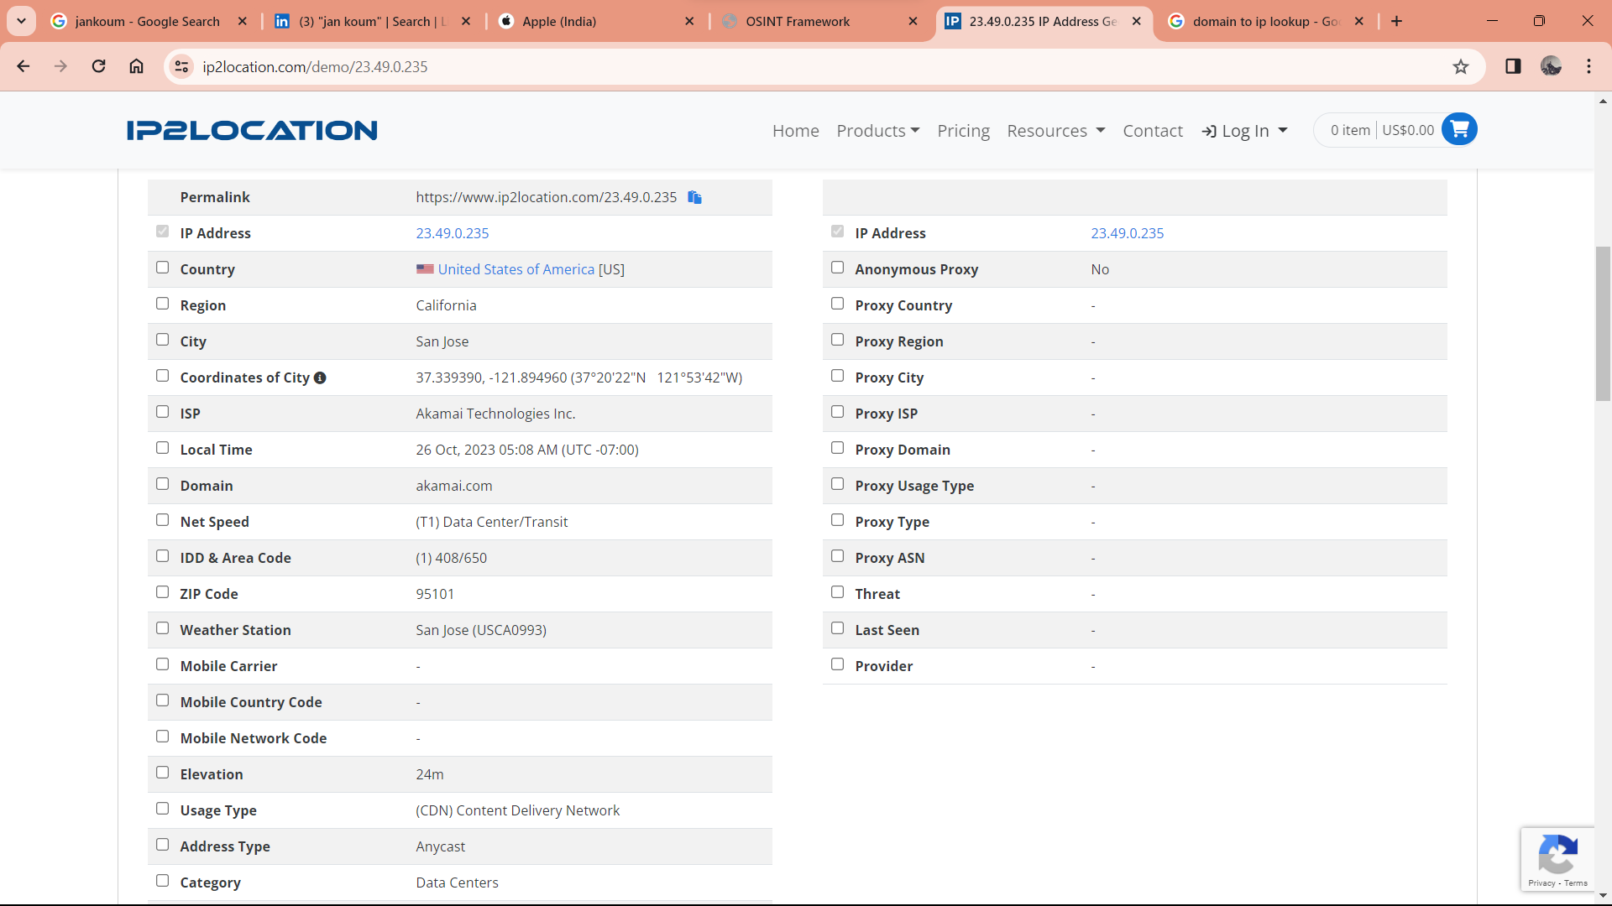

founded on April 1, 1976, by Steve Jobs, Steve Wozniak, and Ronald Wayne as a partnership.

formerly Apple Computer Inc.

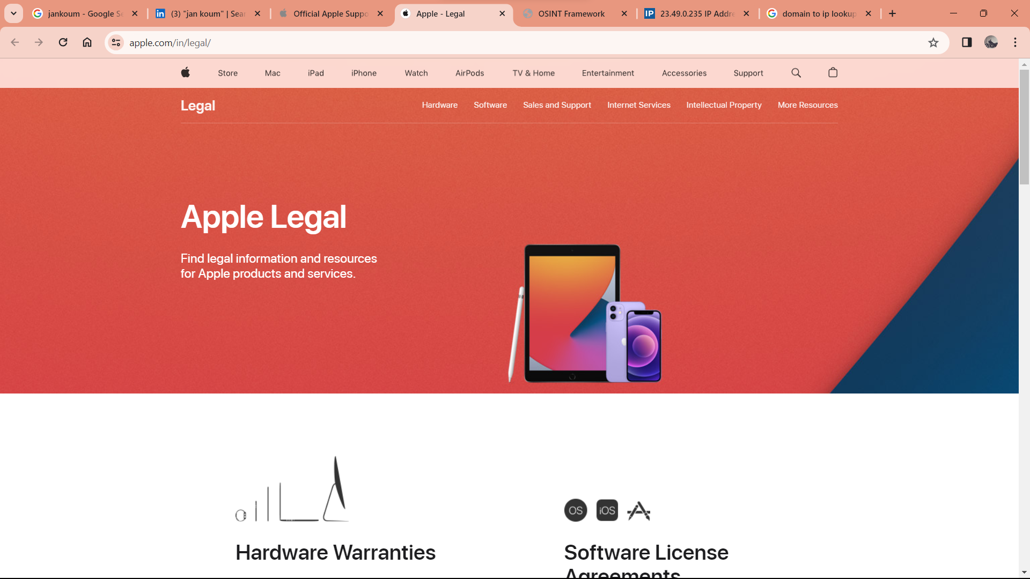

Number to contact apple: 000800 040 1966.

Lines are open Monday–Friday 09:00–18:00

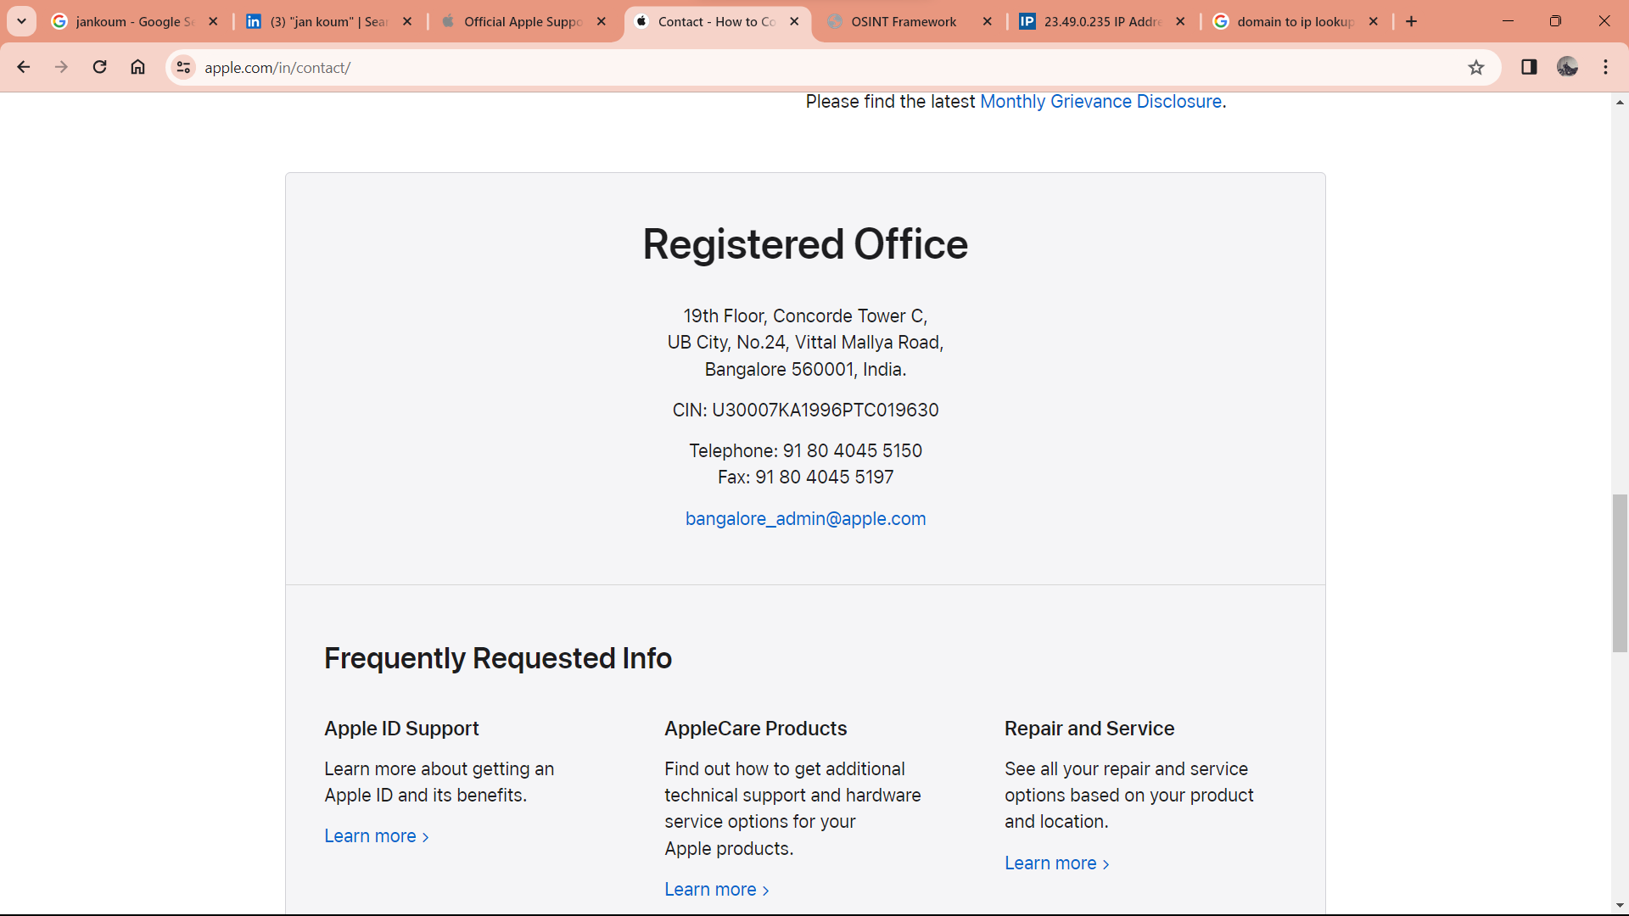

19th Floor, Concorde Tower C,  
UB City, No.24, Vittal Mallya Road,  
Bangalore 560001, India.

CIN: U30007KA1996PTC019630

Telephone: 91 8040455150  
Fax: 91 80 4045 5197

[bangalore_admin@apple.com](mailto:bangalore_admin@apple.com)

**Jennifer Tam**

jennifer_tam@apple.com

**99%**

Save as lead20+ sources

**Cecilia Dou**

cecilia_dou@apple.com

**99%**

Manager

Save as lead1 source

**Brian Weinstein**

bweinstein@apple.com

**99%**

Save as lead6 sources

**Sam Citron**

citron@apple.com

**99%**

Save as lead20+ sources

**Drew Winkelman**

winkelman@apple.com

**99%**

Manager

Save as lead3 sources

**Jeremy Schonfeld**

jschonfeld@apple.com

**99%**

Save as lead1 source

**Harry James**

h.james@apple.com

**99%**

Assistant Manager

Save as lead1 source

**Tom Fuchs**

t_fuchs@apple.com

**99%**

Sales Support

Save as lead1 source

**Giovanni Bossio**

gbossio@apple.com

**99%**

Save as lead20+ sources

**Ellen Loos**

eloos@apple.com

**99%**

+1 703 343 6832

Local Account Executive

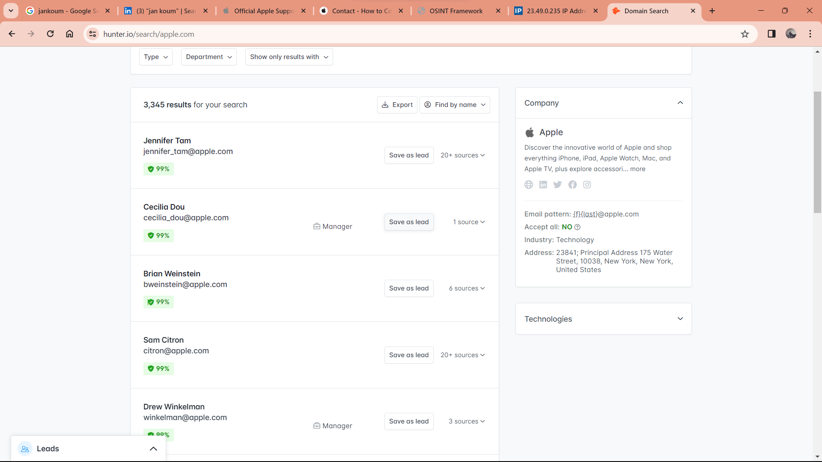

**Apple Park**, also known as **Apple Campus 2**, is the corporate headquarters of [Apple Inc.](https://en.wikipedia.org/wiki/Apple_Inc.), located in [Cupertino, California](https://en.wikipedia.org/wiki/Cupertino,_California), United States. It was opened to employees in April 2017, while construction was still underway, and superseded [Apple Campus](https://en.wikipedia.org/wiki/Apple_Campus) as the company's corporate headquarters, which opened in 1993.[[7]](https://en.wikipedia.org/wiki/Apple_Park#cite_note-7)

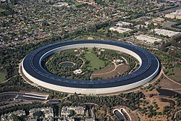

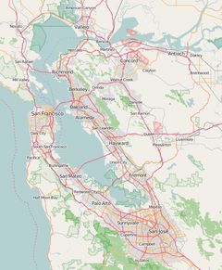

Apple Park is located 1.2 miles (1.9 km) east of the original Apple Campus. Apple has had a presence in Cupertino since 1977, which is why the company decided to build in the area rather than move to a cheaper, distant location. The campus is also next to a contaminated site under Superfund legislation with a groundwater plume found to contain trichloroethylene from improper disposal of industrial waste by semiconductor manufacturers

Cafés

The campus has seven cafés, with the largest being a three-level café for 3,000 sitting people. It has light-colored stone lining and glass railing with no metal support and is surrounded by extensive landscaping. The mezzanine space of 20,000 sq ft (1,900 m2) can accommodate 600 people and 1,750 seats on terraces outside, with a capacity to serve 15,000 lunches a day, housed by specially designed 500 tables made of solid Spessart white oak, measuring 18 ft (5.5 m) long and 4 ft (1.2 m) wide.[citation needed]

The sports tables and benches resemble those in Apple Stores.

**Find My**

* Impact: An app may be able to read sensitive location information
* Description: The issue was addressed with improved handling of caches.
* CVE-2023-40413: Adam M.

**Siri**

* Impact: An attacker with physical access may be able to use Siri to access sensitive user data
* Description: This issue was addressed by restricting options offered on a locked device.
* CVE-2023-41982: Bistrit Dahla

**Weather**

* Impact: An app may be able to access sensitive user data
* Description: A privacy issue was addressed with improved private data redaction for log entries.
* CVE-2023-41254: Cristian Dinca of “Tudor Vianu” National High School of Computer Science, Romania

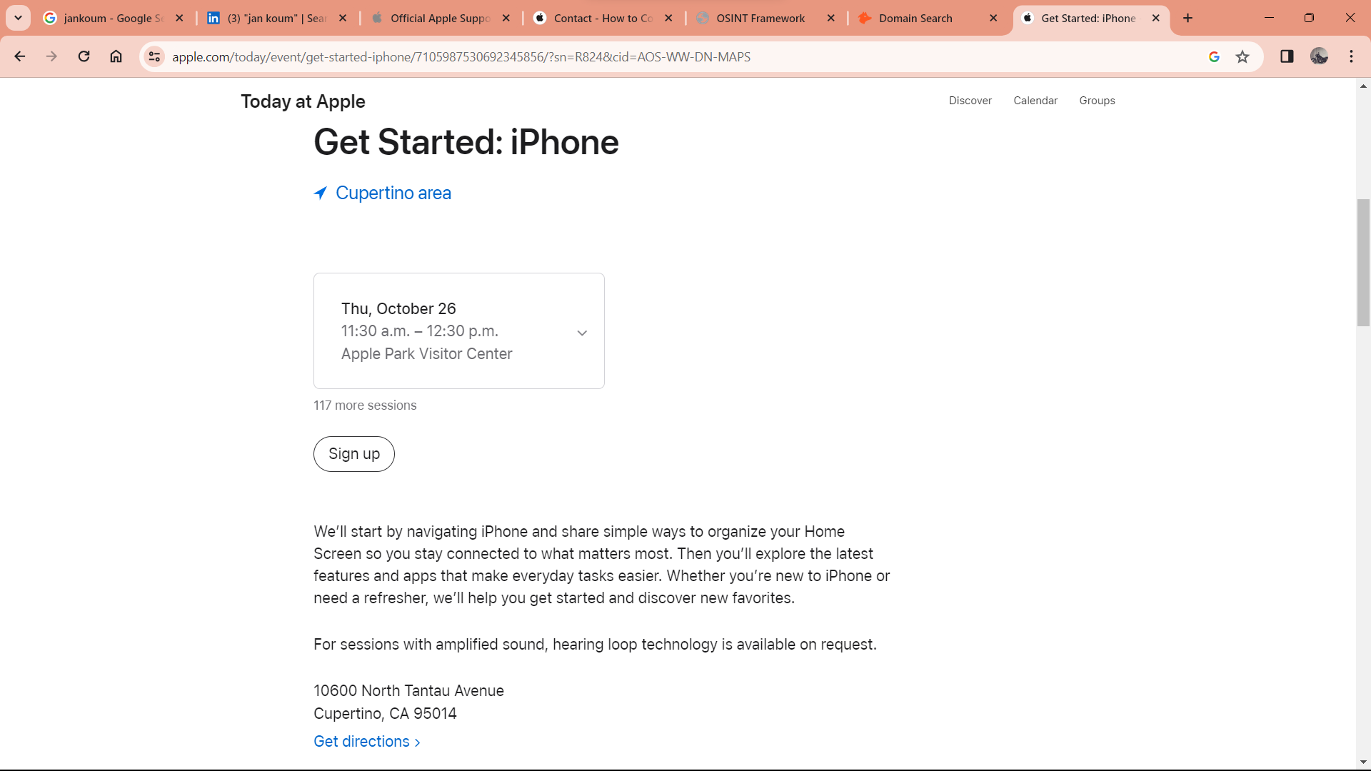

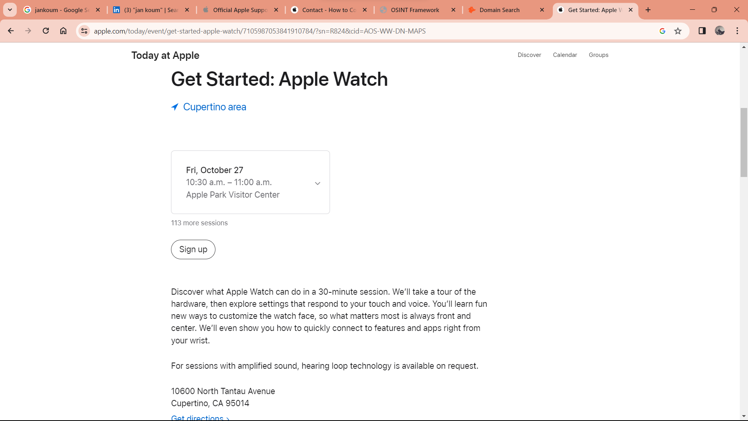

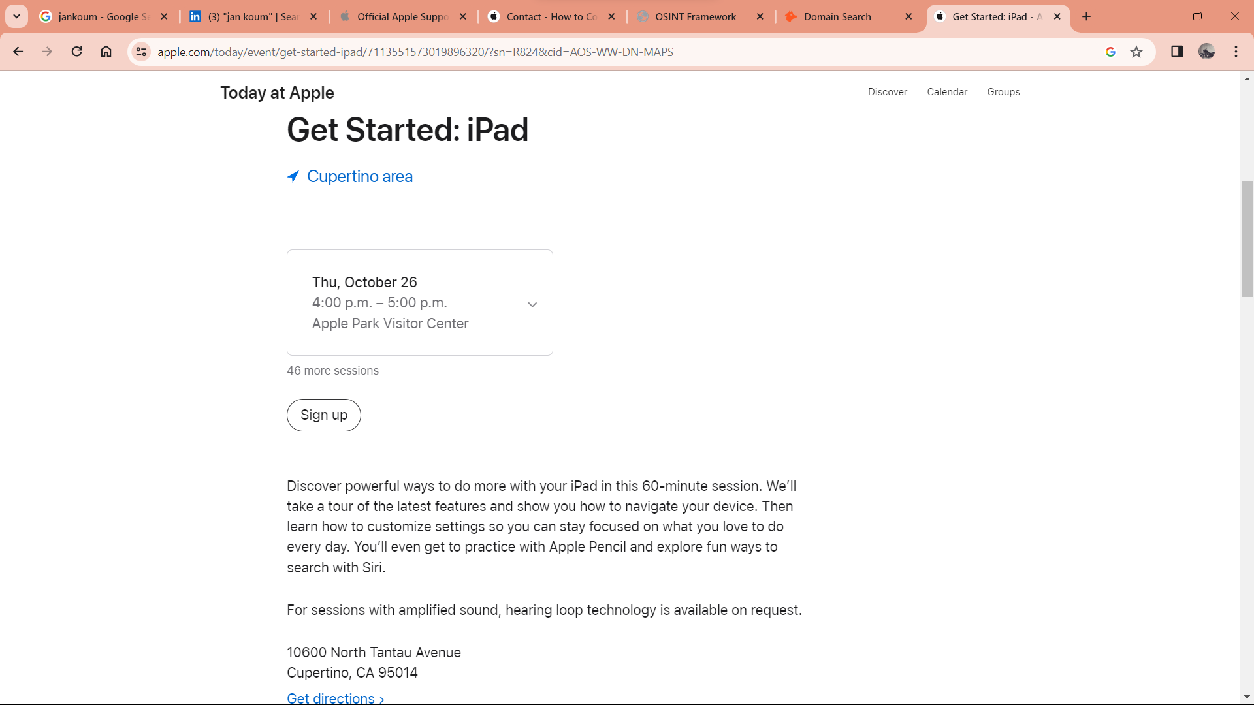

[Tim Cook](https://www.google.com/search?sca_esv=576790596&rlz=1C1CHBF_enIN976IN976&biw=1536&bih=776&sxsrf=AM9HkKlQRy4751Yv8gauok5_VUiiagnFFQ:1698323013150&q=Tim+Cook&stick=H4sIAAAAAAAAAONgVuLUz9U3MC0yM819xGjCLfDyxz1hKe1Ja05eY1Tl4grOyC93zSvJLKkUEudig7J4pbi5ELp4FrFyhGTmKjjn52cDACQSTk1PAAAA&sa=X&ved=2ahUKEwiKj6af2pOCAxUv8TgGHZnRDYEQzIcDKAB6BAgOEAE)

Birth date: November 1, 1960. Birth place: Robertsdale, Alabama.

Steve Jobs, the co-founder and former CEO of Apple Inc., passed away on October 5, 2011. After his death, the company's stock did experience a decline, but it ultimately recovered and has continued to perform well.In the days following his death, Apple's stock fell about 5%, but it had regained those losses by the end of the month. In the years since, the stock has continued to perform well and has seen significant growth. As of today, February 25, 2023, Apple's stock is trading at around $256 per share.

1977 to 1981 – Michael Scott

[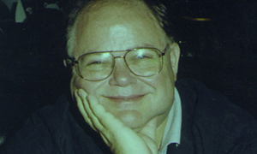](https://thenextweb.com/files/2011/08/michael-scott300.jpeg)Michael Scott came to Apple from National Semiconductor after being persuaded by Apple’s third employee Mike Markkula (more on him later) to take the position as the company’s first CEO as both Steve Jobs and Steve Woziak were seen to be too inexperienced for the role.

### 1983 to 1993 – John Sculley

### 1993 to 1996 – Michael Spindler

### 1996 to 1997 – Gil Amelio

### 1997 to 2011 (with exceptions) – Steve Jobs

### 2011 – Present : Tim Cook

Ronald wayne left the company after 12 days after its inception’

Steve Jobs was sacked from Apple in 1985. He rejoined the company in 1996 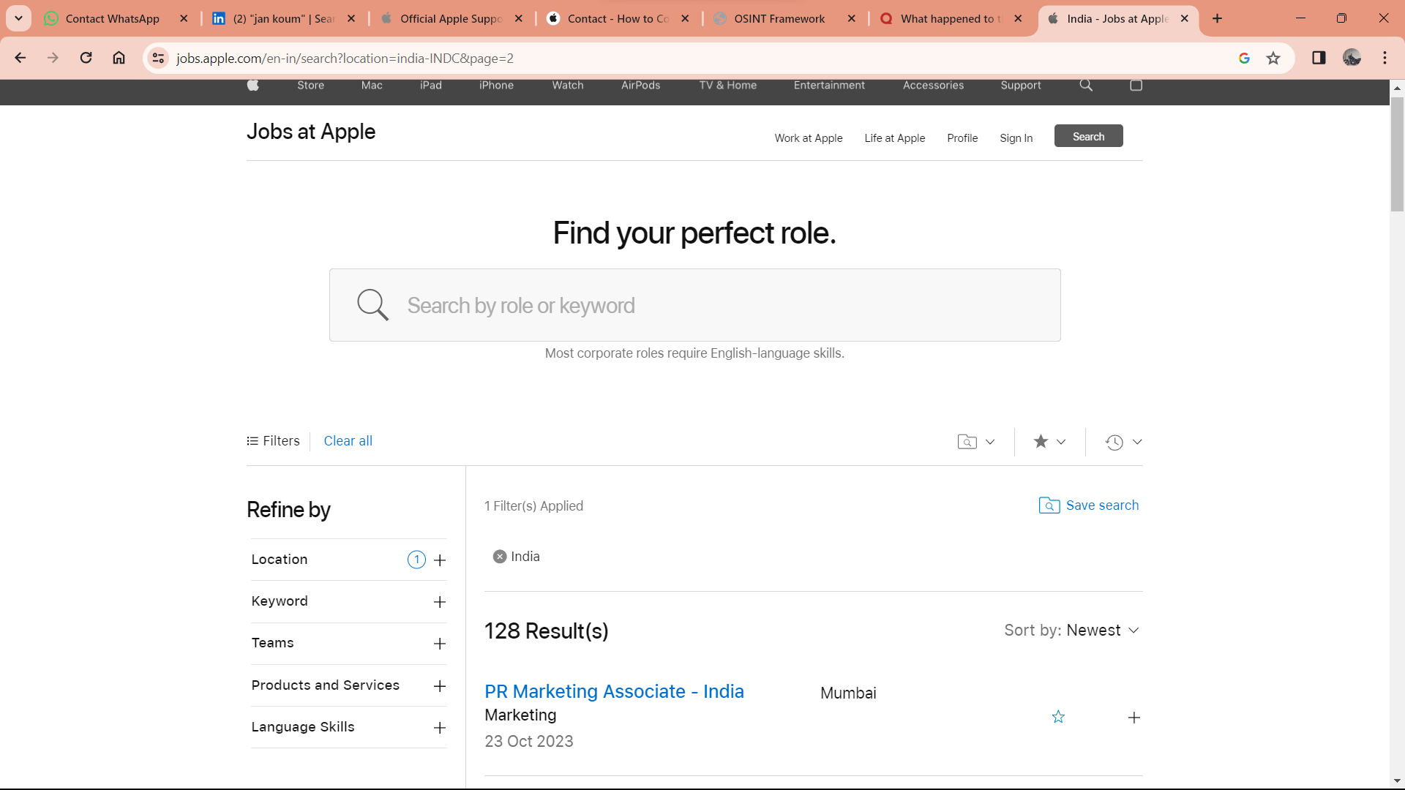https://jobs.apple.com/en-in/search?location=india-INDC&page=2

Nearest ping to apple.com

17.253.144.10

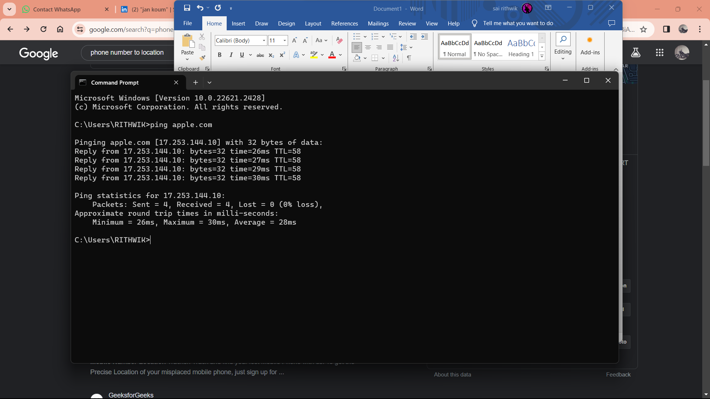

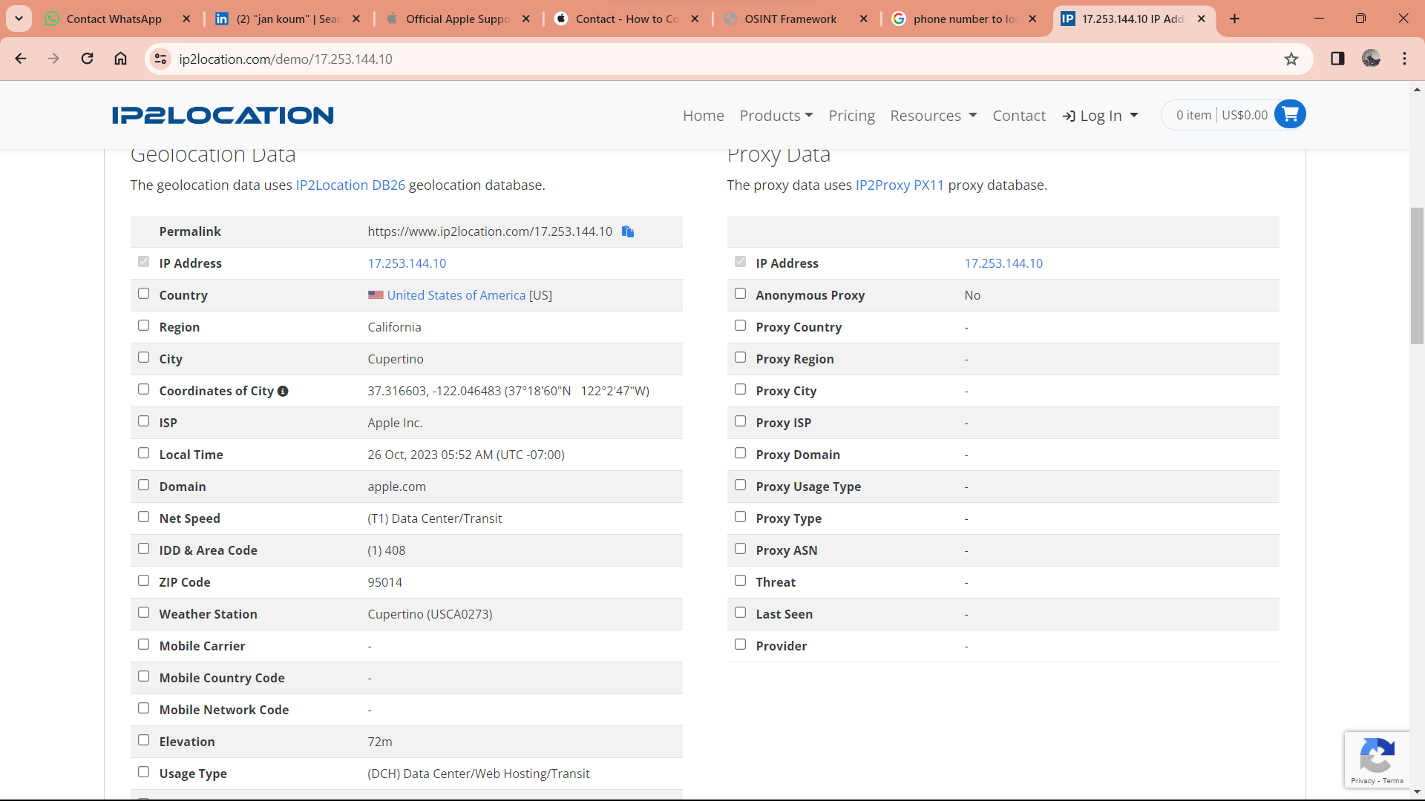

https://www.ip2location.com/demo/17.253.144.10